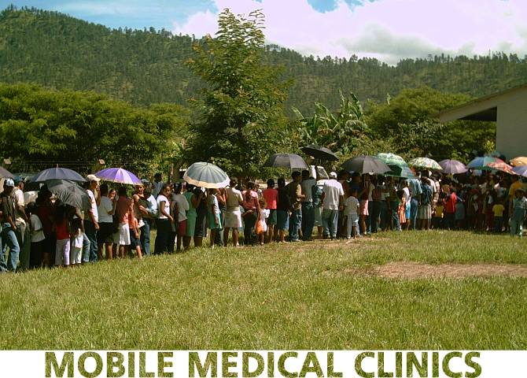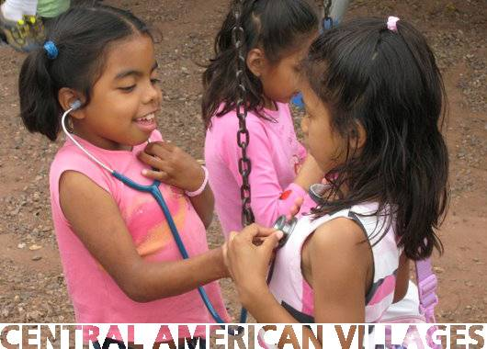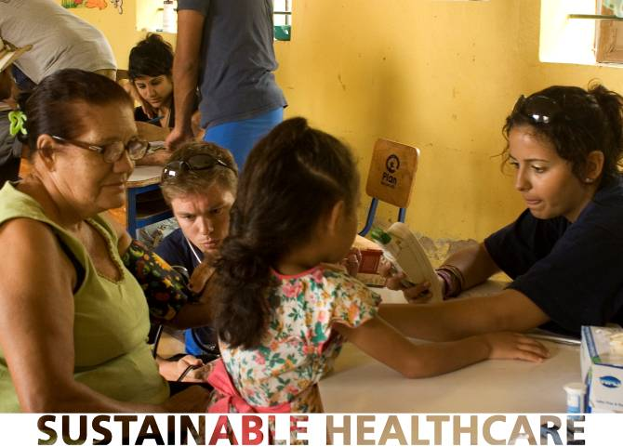

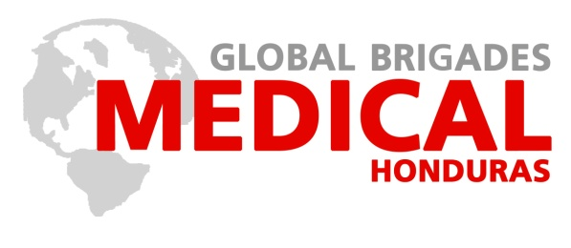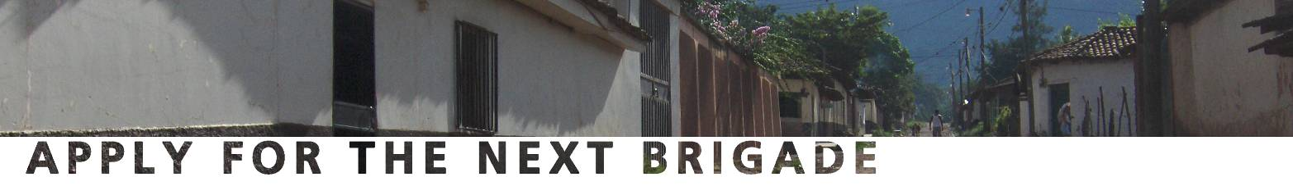

**A 9 day** **Medical Brigade** provides volunteers with the opportunity to make a tangible impact on communities while gaining real life experience in the field of international medicine. Prior to travel, volunteers collect medicines, recruit health professionals and fundraise. Once in Central America, the team will visit two different partner communities to administer day-long clinics and conduct health workshops. The mobile clinic has five stations: *intake* (recording patient demographic information), *triage* (collecting main complaints and vitals), *consultations* (shadowing doctors as they diagnose and prescribe), *pharmacy* (filling prescriptions), and *education* (delivering workshops on preventive healthcare). Evenings prior to each brigade, groups learn from local doctors about the health needs of the specific communities, organize medicine, and delegate duties for the next day.

**Nicaragua** is the current focus of Oregon State’s Medical Brigades, where more than 3,000 annual student volunteers and health professionals travel to establish mobile clinics in under resourced communities. Communities are selected on an extensive study based on need, access to medicine and include a collection of information to create baseline demographic information.

**Important Statistics about our Community Partners:**

* Typically no doctors within a 20 mile radius
* Average family income is less than $1 a day
* 20% of patients have never seen a doctor outside of GMB
* Typical families have less than 3 gallons of water per day to use

**Medical Brigades** develops sustainable health initiatives and provides relief where there is limited access to healthcare. In 2009, 80 Medical Brigades clubs systematically traveled to Central America to establish mobile clinics in 80 of our community partners. Each community receives a brigade every 3 to 4 months where hundreds of patients are treated and volunteers deliver public health workshops. For every Medical Brigades club that is established one more village is able to receive care. Between brigades our in-country team maintains relationships with the communities to provide follow-up and to conduct Community Health Worker (CHW) trainings to empower local leaders to sustain a consistent level of healthcare. Electronic patient records are collected for future visitations and to monitor overall community health trends.

**For more information**

odenk@onid.orst.edu

www.osuglobalbrigades.weebly.com

**Program Contribution**

**Nicaragua $930**

* 9 days
* 3 Meals per day
* Lodging
* In-country travel
* Brigade coordinators

**Brigades Dates:**

June 2014

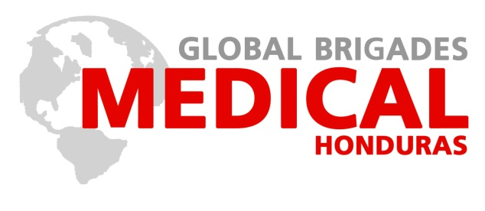



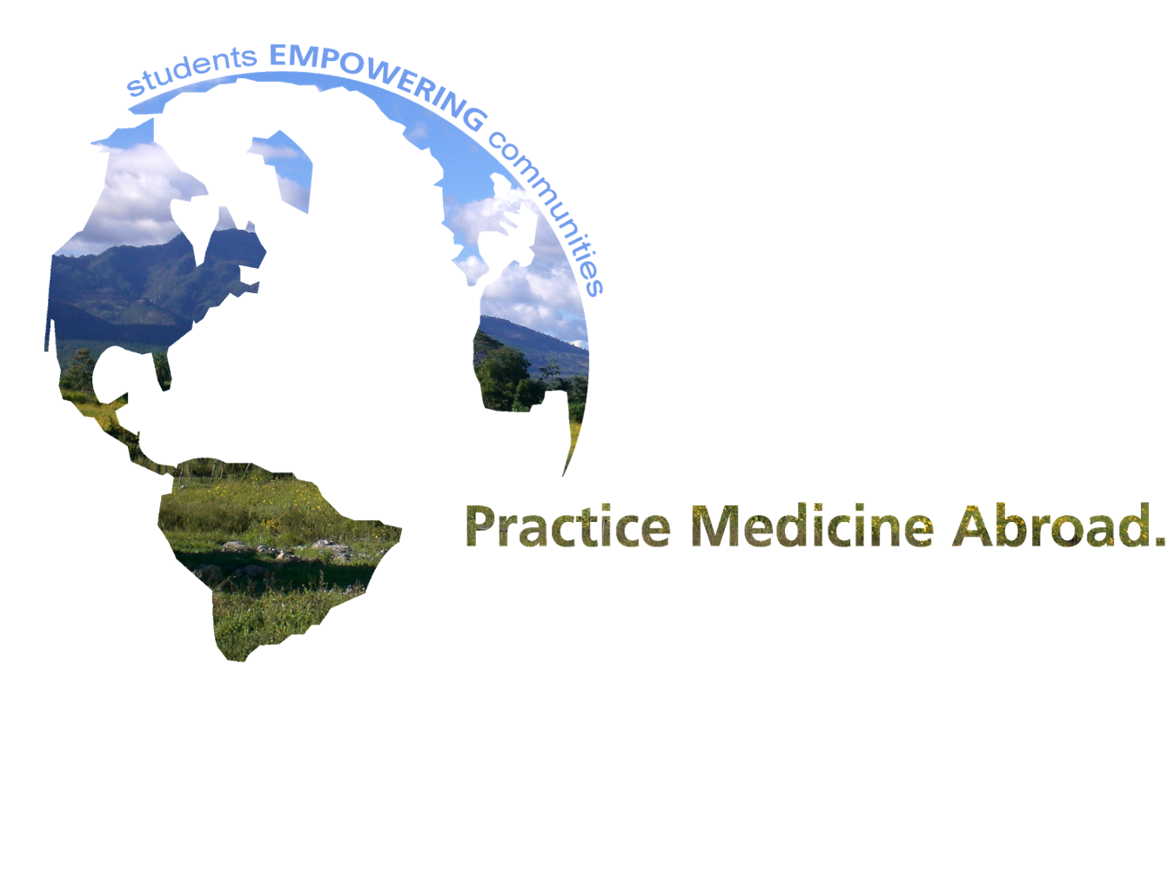

**Next Meeting**

***When*: Fall 2013**

***Where*: Memorial Union**

*Real world medical experience. Real world change.*